Functions in JavaScript

(i)

let result = mul(5,10)

console.log(result)

function mul(a,b){

    return a*b

}

Output:

(ii)

2. let result = mul(5,10)

console.log(result)

function mul(a,b,c=0){

    return a*b*c

}

Output:

Arrow Function:

(i)

multiplication =(a,b)=>{

    return a*b

}

console.log(multiplication(5,10))

output:

(ii)

(ii) multiplication =(a,b)=>

      a*b

console.log(multiplication(5,10))

output:

Spread operator:

const arr = [1,2,3,4,5]

const arr1 = [...arr]

console.log(arr1)

output:

(ii)

const arr = [1,2,3,4,5]

const arr1 = [...arr]

const[one,...rest] = arr

console.log(arr,arr1,one,rest)

output:

**File System:-(CRUD Operation)**

1. create file:- (a) Append

(b) Open

(c) write

2. Read file (Read File())

3. update File (a) Append

(b) write

4. Delete (unlink())

var fs = require('fs');

//Append File

fs.appendFile('file.txt','this is file1',(err)=>{

    if(err) throw err

     console.log('file1 created')

})

// write file

fs.writeFile('file2.txt','this is file2',(err)=>{

            if(err) throw err

            console.log('file2 is created')

})

// open file

fs.open('file3.txt','w',(err)=>{

    if(err) throw err

    console.log('file3 created!')

})

Output:

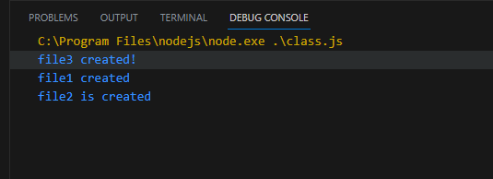

//Read File

Output:

//update File

(i) appendFile()

Output:

(ii) writeFile()

Output:

//Delete (unlink)

Output:

//Rename

Output:

